**Flipbook or page-down pdf: Which is best?**

If you have an e-subscription to the Townships Sun, you know you can go to the TownshipsSun.ca home page, input your email address and password, and view your PDF version of the latest issue in full colour. Every page in full colour! (The same for all the issues from the past year.)

Now you've got a choice―the traditional page-down PDF version, or a new Flipbook version! They're both right there, just a click away.

Here's how the Flipbook version looks.

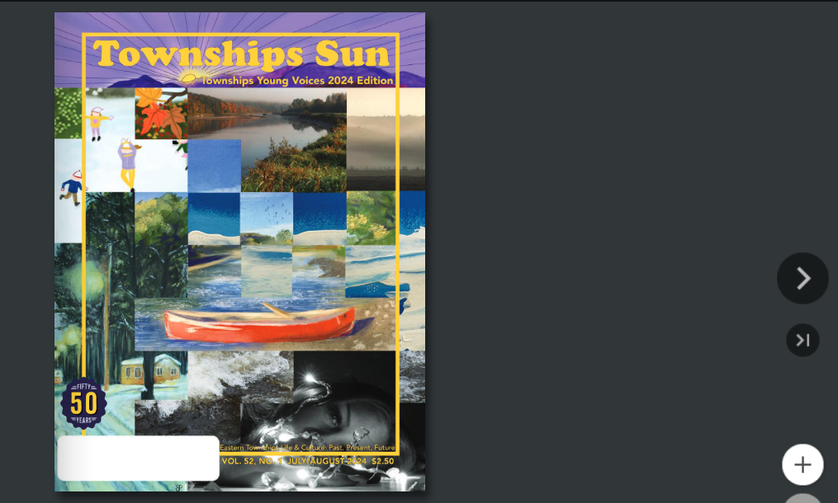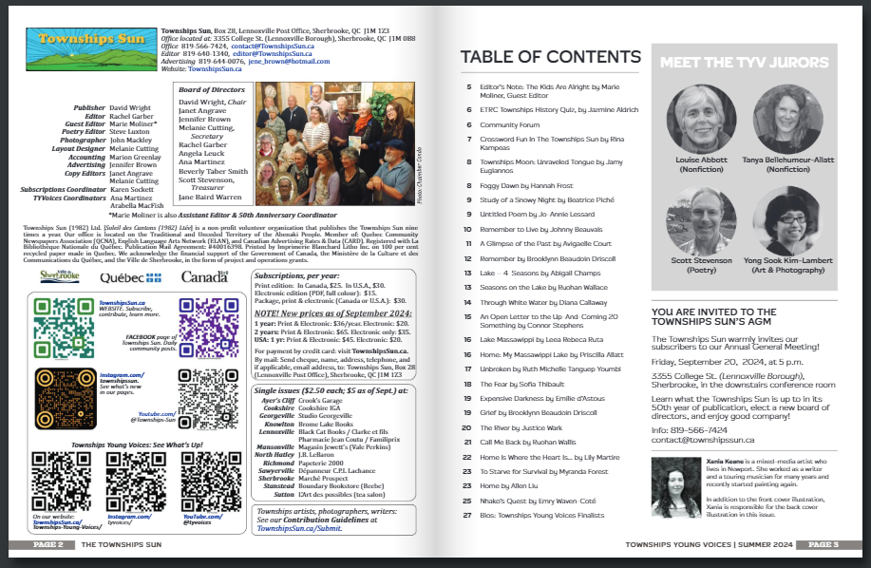

Our question: Which do you prefer? Or do you enjoy both?

Please give us your comments at subscribe@townshipssun.ca.